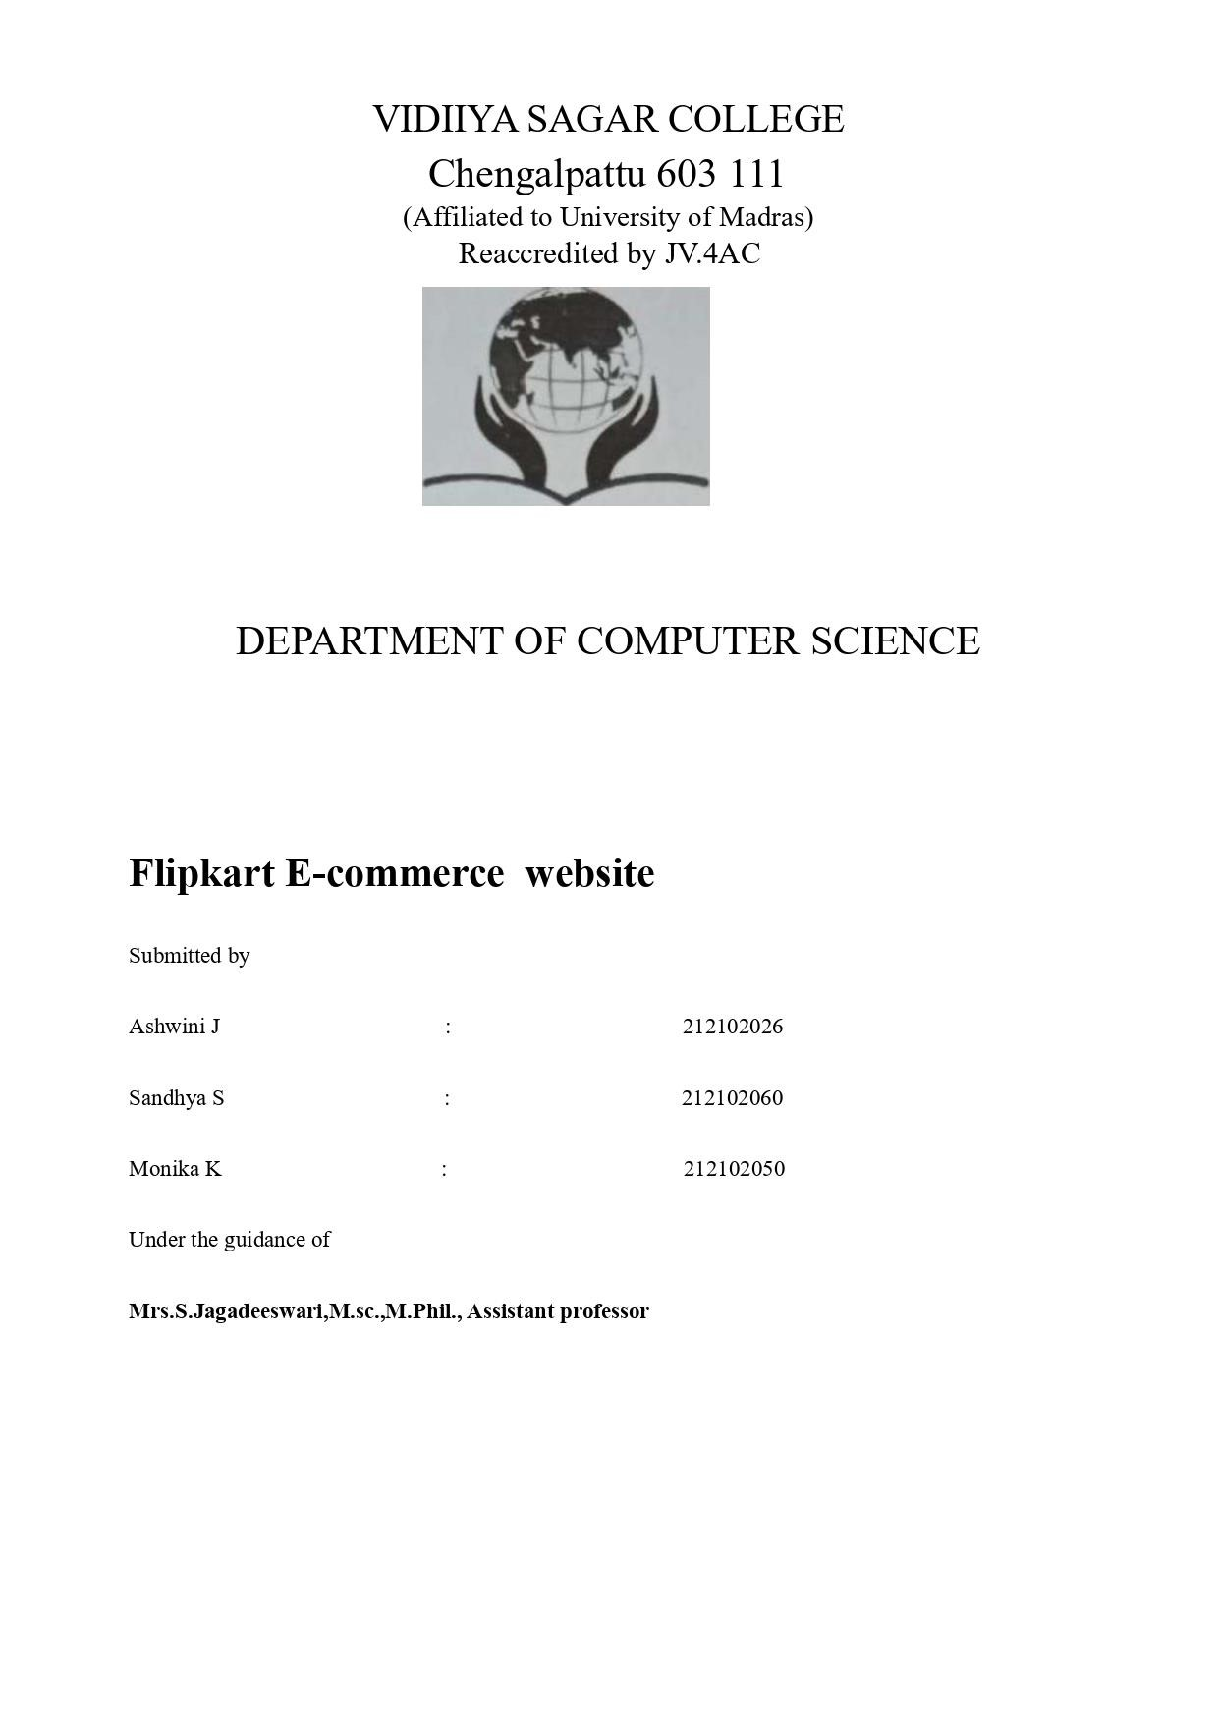

# ACKNOWLEDGEMENT

Presentation, Inspiration and Motivation have always played role in the success of any venture.

First of all, I would like to express my sincere thanks to **Shri .VIKAS SURANA,** Correspondent , Vidhya Sagar Women’s College, Chengalpattu, for his direct and indirect support and encouragement.

I would like to thank **DR. R. Arunadevi, MCA., M.Phil., Ph.D.,** Principal, Vidhya Sagar Women’s College, Chengalpattu, for the useful guidelines and helpful mind to complete the project.

I acknowledgment my wholehearted thanks to **Mr. R. SAMUEL KIRUBAKARAN, Msc.IT, MCA., M.Phil., B.Ed.,** Head of Department, Vidhya Sagar Women’s College, Chengalpattu, who has been helping me a lot for the completion of this project.

I would like to express my deepest gratitude to our project guide, **Mrs. H. SHADIKA MCE., M.Phil., B.Ed., ASSISTANT PROFESSOR** for unwavering support, constant mentoring, and guidance throughout the duration of the project.

I also extended my gratefulness to all Staff members of the Department of Computer Science for their support during my study.

I thank my parents for the constant emotional support during the time period of my project.

# ABSTRACT

Nowadays, the network plays an import role in people’s life. In the process of the improvement of the people’s living standard, people’s demands of the life’s quality and efficiency is more higher, the traditional bookstore’s inconvenience gradually emerge, and the online bookstore has gradually be used in public. The online bookstore is a revolution of book industry. The traditional bookstores’ operation time, address and space is limited, so the types of books and books to find received a degree of restriction. But the online bookstore broke the management mode of traditional bookstore, as long as you have a computer, you can buy the book anywhere, saving time and effort, shortening the time of book selection link effectively. The online bookstore system based on the principle of provides convenience and service to people.

The project contains two main modules. One is Administrator and another one is Customer. The owner of the bookshop is the administrator. He logins to the application and enters the details are Book entry and an Author entry. The book details are ISBN Code, book name, author code, price, discount, net price and number of copies. The author entry contains author code, name and Email Id. From the login, all the orders may be viewed and sales entry is made to the selected order. The order details and sales details can be viewed either auth or-wise, date-wise or book-name wise. The customer may login to the site and register with a user name and password. Then he should enter the personal details such as name and address. He may view the book details searching either author-wise or book-wise and then order for it. The orders made by him and the books given to him can be viewed from the login.

# OBJECTIVES

**Efficiency Enhancement:**

The primary objective of this online bookstore project is to revolutionize the process of acquiring books by introducing a user-friendly platform that streamlines every aspect of the purchasing journey. By leveraging the power of digital technology, we aim to enhance the efficiency of book procurement, allowing customers to swiftly browse through a vast selection of titles, seamlessly select their desired books, and effortlessly complete transactions, all within a few clicks.

**Accessibility:**

In response to the evolving demands of modern consumers, our online bookstore endeavors to transcend the limitations imposed by traditional brick-and-mortar establishments by offering unparalleled accessibility to a diverse array of literary works. Through the convenience of internet connectivity, we aspire to provide customers with unrestricted access to our extensive catalog of books, empowering them to explore, discover, and procure their preferred reading materials from the comfort of their homes or on the go.

**Convenience:**

At the heart of our online bookstore project lies the commitment to deliver unparalleled convenience to our valued customers. By harnessing the power of digital innovation, we strive to redefine the shopping experience, eliminating the logistical hassles associated with physical bookstore visits. Through intuitive navigation, seamless browsing, and secure transactions, our platform aims to offer unparalleled convenience, enabling customers to effortlessly fulfill their literary cravings with just a few clicks.

**User Management:**

Central to the success of our online bookstore project is the facilitation of personalized experiences for our customers through efficient user management functionalities. By providing seamless registration and authentication processes, we empower users to create accounts, manage their profiles, track their orders, and customize their preferences, thereby fostering a sense of belonging and loyalty within our digital community.

**Administrative Control**:

Our online bookstore project is committed to empowering administrators with unparalleled control and flexibility over the digital storefront. From managing book listings and author details to processing orders and sales entries, our comprehensive administrative tools aim to streamline every aspect of bookstore management, ensuring smooth operations and optimal performance at all times.

**Scalability:**

In anticipation of future growth and expansion, our online bookstore project is engineered to be inherently scalable, capable of accommodating increasing user bases, expanding product catalogs, and evolving technological landscapes. Through modular design principles and flexible architecture, we aim to future-proof our platform, ensuring seamless scalability and adaptability to meet the dynamic needs of our growing customer base.

**Security:**

Recognizing the paramount importance of safeguarding sensitive user information and ensuring secure transactions, our online bookstore project prioritizes the implementation of robust security measures at every level of the platform. From encryption protocols and secure authentication mechanisms to stringent data protection policies, we are committed to creating a safe and secure shopping environment that instills trust and confidence in our customers.

**Customer Satisfaction:**

Ultimately, the overarching goal of our online bookstore project is to deliver unparalleled customer satisfaction by prioritizing usability, reliability, and responsiveness throughout the platform. By consistently exceeding customer expectations, we aim to foster long-term loyalty, advocacy, and positive word-of-mouth, solidifying our position as the premier destination for book lovers in the digital age.

# CONTENTS

|  |  |  |
| --- | --- | --- |
| **CHAPTER.NO** | **TOPIC** | **PAGE NO** |
| 1. | INTRODUCTION | 1 |
| 2. | SYSTEM ANALYSIS | 3 |
|  | 2.1) EXISTING SYSTEM | 3 |
|  | 2.2) PROPOSED SYSTEM | 4 |
| 3. | SYSTEM CONFIGURATION | 10 |
|  | 3.1) HARDWARE SPECIFICATION | 10 |
|  | 3.2) SOFTWARE SPECIFICATION | 10 |
| 4. | FLOWCHART | 12 |
| 5. | SOURCE CODE | 13 |
| 6. | SCREENSHOTS | 26 |
| 7. | FUTURE ENHANCEMENT | 28 |
| 8. | CONCLUSION | 29 |
| 9. | BIBLIOGRAPHY | 30 |

**CHAPTER-1**

## 1.INTRODUCTION

The Online Bookstore website is an online platform that provides users with the convenience of browsing, searching and purchasing books from the comfort of their own homes. The website aims to make the book buying process easier and more accessible to users, eliminating the need to physically visit a bookstore. With a user-friendly interface and a vast selection of books, the Online Bookstore website offers a comprehensive solution for book enthusiasts who are looking for a hassle-free book buying experience.

The website offers an extensive selection of books from various categories such as Fiction, Non-fiction, Romance, Mystery, and many more. Users can search for books based on specific keywords, browse through different categories, and purchase books using their credit card or other payment methods. The website also provides users with detailed information about each book, including its cover image, author, publisher, ISBN, price, and description. In addition to providing users with the ability to browse and purchase books, the Online Bookstore website also offers features such as user registration, order history, and shopping cart.

Users can create an account on the website, view their previous orders, and track the status of their current orders. The shopping cart feature allows users to add books to their cart and purchase them in a single transaction, making the book buying process more efficient.

The online bookstore system can not only reduce costs, save time, space, to bring convenience to everyone, but also to promote the development of the logistics industry, serve three purposes, mutual benefit. More importantly, in today's world, the increasingly close ties between countries, more frequent exchanges, the economy tends to globalization, which promote the future development of online bookstore system has some practical significance.

Overall, the Online Bookstore website is an excellent solution for book enthusiasts who are looking for a convenient and accessible way to purchase books online. With its vast selection of books, user-friendly interface, and comprehensive features, the website offers a comprehensive solution for users looking for a hassle-free book buying experience.

**CHAPTER – 2**

## 2.SYSTEM ANALYSIS

### 2.1 EXISTING SYSTEM

The existing system for our online bookstore project encompasses a comprehensive platform designed to cater to the diverse needs of both administrators and customers. At its core, the system features two main modules: Administrator and Customer. Administrators, serving as the proprietors of the bookstore, access the system to manage essential operations such as book and author entries. They can efficiently input details including ISBN codes, book names, author information, prices, discounts, and inventory quantities. Furthermore, administrators oversee order management, with the ability to view all orders and input sales data seamlessly. The system facilitates flexible viewing options, allowing administrators to access order and sales details either author-wise, date-wise, or book-name wise, providing valuable insights into business performance. On the customer front, the system offers an intuitive interface for users to register accounts, input personal details, and browse through the extensive collection of books. Customers can easily search for books by author or title, place orders, and track their purchase history effortlessly. With its robust functionality and user-friendly design, the existing system sets the foundation for a seamless and rewarding online shopping experience for both administrators and customers alike.

In addition to the core functionalities, the existing system boasts several supplementary features aimed at enriching the overall user experience and enhancing operational efficiency. Among these enhancements is a dynamic recommendation engine that leverages user browsing history, purchase patterns, and preferences to offer personalized book recommendations, thereby aiding customers in discovering new and relevant titles tailored to their interests. Furthermore, the system incorporates a sophisticated review and rating system, empowering users to share their thoughts and experiences with fellow book enthusiasts, fostering a sense of community and facilitating informed purchasing decisions. To further streamline the checkout process, the system integrates with multiple payment gateways, providing customers with a variety of secure and convenient payment options to choose from. Moreover, to ensure transparency and accountability, the system generates detailed invoices for each transaction, providing users with comprehensive summaries of their purchases. Additionally, administrators have access to advanced analytics dashboards, allowing them to gain deeper insights into sales trends, customer behavior, and inventory performance, thereby enabling data-driven decision-making and strategic planning. With these additional features, the existing system not only meets the functional requirements of an online bookstore but also surpasses expectations, setting the stage for continued growth and success in the dynamic digital marketplace.

### 2.2 PROPOSED SYSTEM

The proposed system for the "Online Book Store" project aims to significantly enhance the existing platform by leveraging the capabilities of MySQL and PHP with XAMPP to deliver a robust, user-friendly, and efficient online shopping experience for both administrators and customers. The system will retain the core functionalities of the current platform while introducing several enhancements and optimizations to elevate its performance and usability.

Leveraging the power of PHP for server-side scripting and MySQL for database management, the system will dynamically generate web pages that allow customers to easily browse, search, and purchase books from the extensive catalog. The interface will be optimized for compatibility with various web browsers and devices, ensuring seamless access for users across different platforms.

To enhance discoverability and personalized recommendations, the proposed system will implement custom-built algorithms using PHP and MySQL to analyze user preferences, browsing history, and purchase patterns. These algorithms will generate personalized book recommendations for each user, helping them discover new titles and authors that align with their interests. Additionally, the system will enable users to create accounts, manage their profiles, and track their order history, providing a personalized and engaging shopping experience.

On the administrative side, the proposed system will introduce advanced tools and functionalities to streamline inventory management, order processing, and reporting. Administrators will be able to efficiently manage book listings, update inventory quantities, and track sales data using intuitive web-based interfaces powered by PHP and MySQL. The system will also generate detailed reports and analytics dashboards to provide administrators with valuable insights into sales performance, customer behavior, and inventory trends, enabling data-driven decision-making and strategic planning.

In terms of security, the proposed system will prioritize the implementation of robust security measures using PHP and MySQL to protect sensitive user information, payment transactions, and system integrity. This will include secure user authentication mechanisms, data encryption techniques, and regular security audits to identify and mitigate potential vulnerabilities. By adhering to best practices in web security, the system will ensure a safe and secure shopping environment for both administrators and customers.

**CHAPTER – 3**

## 3.SYSTEM CONFIGURATION

### 3.1 HARDWARE SPECIFICATION

### For the "Online Book Store" project, the hardware requirements are relatively modest, as the system primarily relies on software components such as PHP and MySQL running on a server environment provided by XAMPP. Below are the basic hardware requirements:

### Server:

### A computer capable of running the XAMPP stack, which includes Apache (web server), MySQL (database server), PHP (scripting language), and Perl.

### Recommended specifications:

### Processor: Dual-core or higher

### RAM: 2GB or more

### Storage: Sufficient disk space for storing website files and database data

### Network Connectivity:

### Reliable internet connection to host the online bookstore website and facilitate communication between the server and users' devices.

### Backup System:

### External storage or cloud backup solution to regularly back up website files and database data to prevent data loss in case of hardware failure or other emergencies.

### Optional:

### Load balancer (for scalability and redundancy)

### Dedicated firewall or security appliance for enhanced network security

### 3.2 SOFTWARE SPECIFICATION

The Online Bookstore website will be developed using modern web development technologies and will require a web server, a domain name, and a database server to function correctly. The following system requirements are necessary to run the website:

1. **Web Server**: The website will require a web server that supports PHP and MySQL. Apache or Nginx are recommended web servers for hosting the website.
2. **Domain Name:** The website will require a domain name to access it. The domain name should be registered with a domain registrar and should point to the website's IP address.
3. **Database Server:** The website will require a database server that supports MySQL. MySQL server should be installed and configured on the web server.
4. **Operating System:** The website can be developed on any operating system such as Windows, macOS, or Linux.
5. **Web Browser:** The website will be accessible from any modern web browser such as Google Chrome, Mozilla Firefox, or Microsoft Edge.
6. **PHP Version:** The website will require PHP version 7.0 or higher.
7. **MySQL Version:** The website will require MySQL version 5.7 or higher.
8. **HTML, CSS, and JavaScript**: The website will be developed using HTML, CSS, and JavaScript.
9. **Text Editor:** A text editor such as Visual Studio Code, Atom, or Sublime Text will be required for development.
10. **Payment Gateway Integration:** The website will require integration with a payment gateway such as PayPal or Stripe to process online payments.
11. **SSL Certificate:** The website will require an SSL certificate to ensure secure communication between the user's browser and the web server.
12. **Responsive Design:** The website will be designed with a responsive design that can adapt to different screen sizes and devices.

The system requirements listed above are essential for the development and deployment of the Online Bookstore website. The website's performance and functionality will depend on the ~ 53 ~ quality of the web server, database server, and payment gateway integration. It is essential to ensure that the system requirements are met to ensure a smooth and hassle-free user experience.

**CHAPTER – 4**

## 4. FLOWCHART

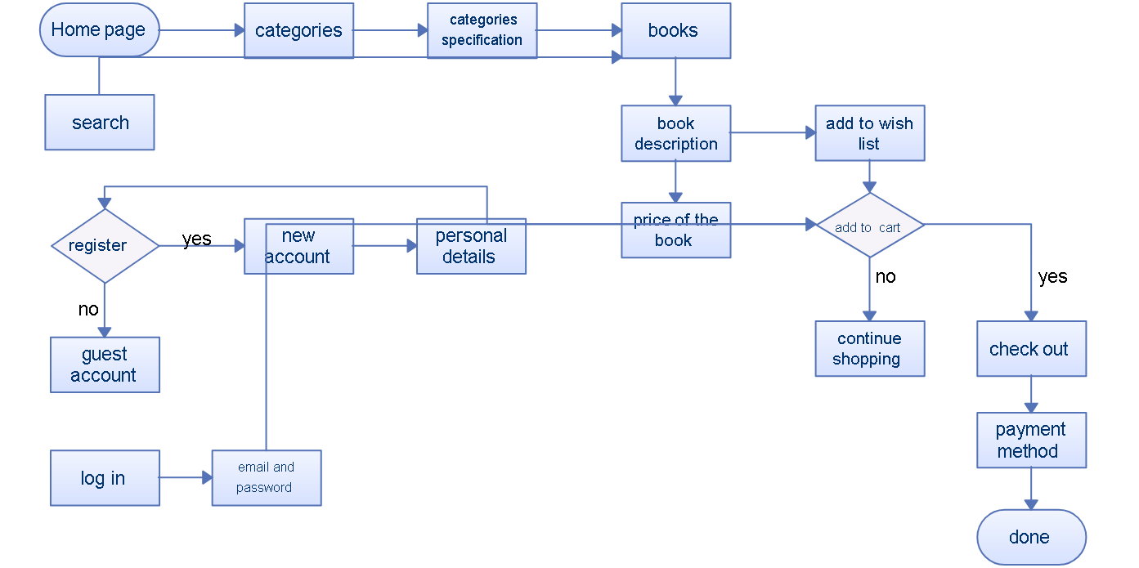

Fig 4.1

## CHAPTER – 5

**5.SOURCE CODE**

**Admin.php**

<?php

$title = "Administration section"; require_once "./template/header.php";

?>

<div class="form-group">

<label for="name" class="control-label col-md-4">Name</label>

<div class="col-md-4">

<input type="text" name="name" class="form-control">

</div>

</div>

<div class="form-group">

<label for="pass" class="control-label col-md-4">Pass</label>

<div class="col-md-4">

<input type="password" name="pass" class="form-control">

</div>

</div>

<input type="submit" name="submit" class="btn btn-primary">

</form>

<?php

require_once "./template/footer.php";

?>

## Admin_Add.php

<?php

session_start();

require_once "./functions/admin.php";

$title = "Add new book"; require "./template/header.php"; require "./functions/database_functions.php";

$conn = db_connect();

if(isset($_POST['add'])){

$isbn = trim($_POST['isbn']);

$isbn = mysqli_real_escape_string($conn, $isbn);

$title = trim($_POST['title']);

$title = mysqli_real_escape_string($conn, $title);

$author = trim($_POST['author']);

$author = mysqli_real_escape_string($conn, $author);

$descr = trim($_POST['descr']);

$descr = mysqli_real_escape_string($conn, $descr);

$price = floatval(trim($_POST['price']));

$price = mysqli_real_escape_string($conn, $price);

$publisher = trim($_POST['publisher']);

$publisher = mysqli_real_escape_string($conn, $publisher);

// add image

if(isset($_FILES['image']) && $_FILES['image']['name'] != ""){ $image = $_FILES['image']['name'];

$directory_self = str_replace(basename($_SERVER['PHP_SELF']), '', $_SERVER['PHP_SELF']);

$uploadDirectory = $_SERVER['DOCUMENT_ROOT'] . $directory_self .

"bootstrap/img/";

$uploadDirectory .= $image;

move_uploaded_file($_FILES['image']['tmp_name'], $uploadDirectory);

}

// find publisher and return pubid

// if publisher is not in db, create new

$findPub = "SELECT * FROM publisher WHERE publisher_name = '$publisher'";

$findResult = mysqli_query($conn, $findPub); if(!$findResult){

// insert into publisher table and return id

$insertPub = "INSERT INTO publisher(publisher_name) VALUES

('$publisher')";

$insertResult = mysqli_query($conn, $insertPub); if(!$insertResult){

echo "Can't add new publisher " . mysqli_error($conn);

exit;

}

$publisherid = mysql_insert_id($conn);

} else {

$row = mysqli_fetch_assoc($findResult);

$publisherid = $row['publisherid'];

}

$query = "INSERT INTO books VALUES ('" . $isbn . "', '" . $title . "', '" . $author . "', '" .

$image . "', '" . $descr . "', '" . $price . "', '" . $publisherid . "')";

$result = mysqli_query($conn, $query); if(!$result){

echo "Can't add new data " . mysqli_error($conn);

exit;

} else {

header("Location: admin_book.php");

}

}

?>

<form method="post" action="admin_add.php" enctype="multipart/form-data">

<table class="table">

<tr>

<th>ISBN</th>

<td><input type="text" name="isbn"></td>

</tr>

<tr>

<th>Title</th>

<td><input type="text" name="title" required></td>

</tr>

<tr>

<th>Author</th>

<td><input type="text" name="author" required></td>

</tr>

<tr>

<th>Image</th>

<td><input type="file" name="image"></td>

</tr>

<tr>

<th>Description</th>

<td><textarea name="descr" cols="40" rows="5"></textarea></td>

</tr>

<tr>

<th>Price</th>

<td><input type="text" name="price" required></td>

</tr>

<tr>

<th>Publisher</th>

<td><input type="text" name="publisher" required></td>

</tr>

</table>

<input type="submit" name="add" value="Add new book" class="btn btn-primary">

<input type="reset" value="cancel" class="btn btn-default">

</form>

<br/> <?php

if(isset($conn)) {mysqli_close($conn);} require_once "./template/footer.php";

?>

## Admin_book.php

<?php

session_start();

require_once "./functions/admin.php";

$title = "List book";

require_once "./template/header.php"; require_once "./functions/database_functions.php";

$conn = db_connect();

$result = getAll($conn);

?>

<p class="lead"><a href="admin_add.php">Add new book</a></p>

<a href="admin_signout.php" class="btn btn-primary">Sign out!</a>

<table class="table" style="margin-top: 20px">

<tr>

<th>ISBN</th>

<th>Title</th>

<th>Author</th>

<th>Image</th>

<th>Description</th>

<th>Price</th>

<th>Publisher</th>

<th>&nbsp;</th>

<th>&nbsp;</th>

</tr>

<?php while($row = mysqli_fetch_assoc($result)){ ?>

<tr>

<td><?php echo $row['book_isbn']; ?></td>

<td><?php echo $row['book_title']; ?></td>

<td><?php echo $row['book_author']; ?></td>

<td><?php echo $row['book_image']; ?></td>

<td><?php echo $row['book_descr']; ?></td>

<td><?php echo $row['book_price']; ?></td>

<td><?php echo getPubName($conn, $row['publisherid']); ?></td>

<td><a href="admin_edit.php?bookisbn=<?php echo $row['book_isbn'];

?>">Edit</a></td>

<td><a href="admin_delete.php?bookisbn=<?php echo $row['book_isbn']; ?>">Delete</a></td>

</tr>

<?php } ?>

</table>

<?php

if(isset($conn)) {mysqli_close($conn);} require_once "./template/footer.php";

?>

## Admin_delete.php

<?php

$book_isbn = $_GET['bookisbn'];

require_once "./functions/database_functions.php";

$conn = db_connect();

$query = "DELETE FROM books WHERE book_isbn = '$book_isbn'";

$result = mysqli_query($conn, $query); if(!$result){

echo "delete data unsuccessfully " . mysqli_error($conn); exit;

}

header("Location: admin_book.php");

?>

## Purchase_list.php

<?php

session_start(); require_once "./functions/database_functions.php";

$conn = db_connect();

$query = "SELECT * FROM publisher ORDER BY publisherid";

$result = mysqli_query($conn, $query); if(!$result){

echo "Can't retrieve data " . mysqli_error($conn);

exit;

}

if(mysqli_num_rows($result) == 0){ echo "Empty publisher ! Something wrong! check again"; exit;

}

$title = "List Of Publishers"; require "./template/header.php";

?>

<p class="lead">List of Publisher</p>

<ul>

<?php while($row = mysqli_fetch_assoc($result)){

$count = 0;

$query = "SELECT publisherid FROM books";

$result2 = mysqli_query($conn, $query); if(!$result2){

echo "Can't retrieve data " . mysqli_error($conn);

exit;

}

while ($pubInBook = mysqli_fetch_assoc($result2)){ if($pubInBook['publisherid'] == $row['publisherid']){

$count++;

}

}

?>

<li>

<span class="badge"><?php echo $count; ?></span>

<a href="bookPerPub.php?pubid=<?php echo $row['publisherid']; ?>"><?php echo $row['publisher_name']; ?></a>

</li>

<?php } ?>

<li>

<a href="books.php">List full of books</a>

</li>

</ul> <?php mysqli_close($conn); require "./template/footer.php";

?>

## Purchase.php

<?php

session_start(); $_SESSION['err'] = 1; foreach($_POST as $key => $value){ if(trim($value) == ''){

$_SESSION['err'] = 0;

}

break;

}

if($_SESSION['err'] == 0){ header("Location: checkout.php");

} else {

unset($_SESSION['err']);

}

$_SESSION['ship'] = array(); foreach($_POST as $key => $value){ if($key != "submit"){

$_SESSION['ship'][$key] = $value;

}

}

require_once "./functions/database_functions.php";

// print out header here $title = "Purchase"; require "./template/header.php";

// connect database if(isset($_SESSION['cart']) && (array_count_values($_SESSION['cart']))){

?>

<table class="table">

<tr>

<th>Item</th>

<th>Price</th>

<th>Quantity</th>

<th>Total</th>

</tr>

<?php foreach($_SESSION['cart'] as $isbn => $qty){

$conn = db_connect();

$book = mysqli_fetch_assoc(getBookByIsbn($conn, $isbn));

?>

<tr>

<td><?php echo $book['book_title'] . " by " . $book['book_author']; ?></td>

<td><?php echo "$" . $book['book_price']; ?></td>

<td><?php echo $qty; ?></td>

<td><?php echo "$" . $qty * $book['book_price']; ?></td>

</tr>

<?php } ?>

<tr>

<th>&nbsp;</th>

<th>&nbsp;</th>

<th><?php echo $_SESSION['total_items']; ?></th>

<th><?php echo "$" . $_SESSION['total_price']; ?></th>

</tr>

<tr>

<td>Shipping</td>

<td>&nbsp;</td>

<td>&nbsp;</td>

<td>20.00</td>

</tr>

<tr>

<th>Total Including Shipping</th>

<th>&nbsp;</th>

<th>&nbsp;</th>

<th><?php echo "$" . ($_SESSION['total_price'] + 20); ?></th>

</tr>

</table>

<form method="post" action="process.php" class="form-horizontal">

<?php if(isset($_SESSION['err']) && $_SESSION['err'] == 1){ ?>

<p class="text-danger">All fields have to be filled</p>

<?php } ?>

<div class="form-group">

<label for="card_type" class="col-lg-2 control-label">Type</label>

<div class="col-lg-10">

<select class="form-control" name="card_type">

<option value="VISA">VISA</option>

<option value="MasterCard">MasterCard</option>

<option value="American Express">American Express</option>

</select>

</div>

</div>

<div class="form-group">

<label for="card_number" class="col-lg-2 control-label">Number</label>

<div class="col-lg-10">

<input type="text" class="form-control" name="card_number">

</div>

</div>

<div class="form-group">

<label for="card_PID" class="col-lg-2 control-label">PID</label>

<div class="col-lg-10">

<input type="text" class="form-control" name="card_PID">

</div>

</div>

<div class="form-group">

<label for="card_expire" class="col-lg-2 control-label">Expiry Date</label>

<div class="col-lg-10">

<input type="date" name="card_expire" class="form-control">

</div>

</div>

<div class="form-group">

<label for="card_owner" class="col-lg-2 control-label">Name</label>

<div class="col-lg-10">

<input type="text" class="form-control" name="card_owner">

</div>

</div>

<div class="form-group">

<div class="col-lg-10 col-lg-offset-2">

<button type="reset" class="btn btn-default">Cancel</button>

<button type="submit" class="btn btn-primary">Purchase</button>

</div>

</div>

</form>

<p class="lead">Please press Purchase to confirm your purchase, or Continue Shopping to add or remove items.</p>

<?php

} else {

echo "<p class=\"text-warning\">Your cart is empty! Please make sure you add some books in it!</p>";

}

if(isset($conn)){ mysqli_close($conn); } require_once "./template/footer.php";

?>

## Verify.php

<?php

$email = $_POST['inputEmail'];

$pswd = $_POST['inputPasswd'];

$conn = mysqli_connect("localhost", "root", "", "www_project");

if(!$conn){ echo "Cannot connecto to database " . mysqli_connect_error($conn);

exit;

}

$query = "SELECT username, password FROM admin";

$result = mysqli_query($conn, $query); if(!$result){

echo "Empty!"; exit;}

while ($row = mysqli_fetch_assoc($result)){ if($email == $row['username'] && $pswd == $row['password']){ echo "Welcome admin! Long time no see";

break;

}

}

?>

## CHAPTER -6

## 6. SCREENSHOTS

### Home Page:

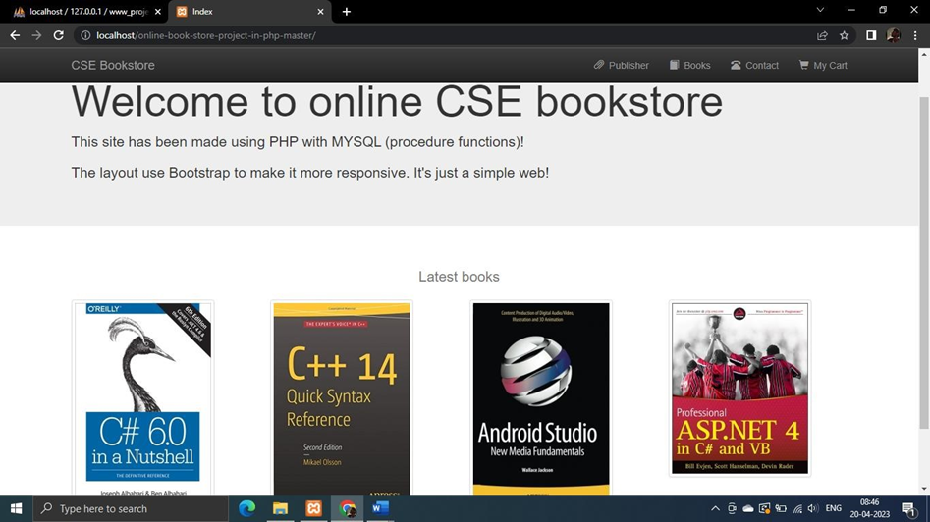

**List of publisher:**

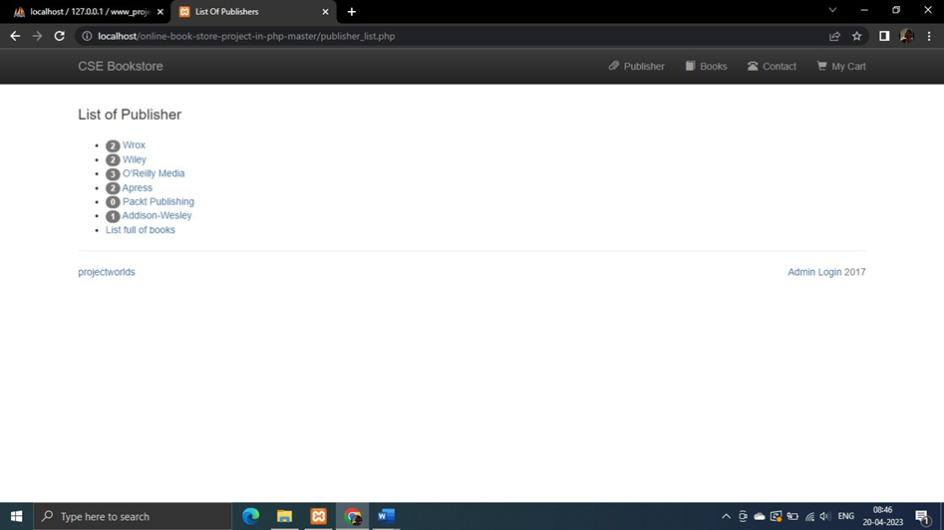

**List of all books:**

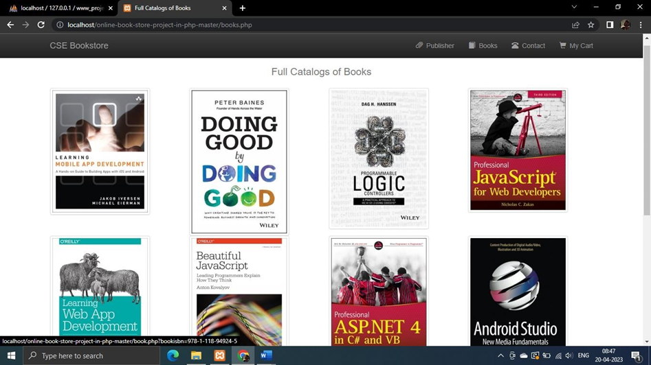

**Contact details:**

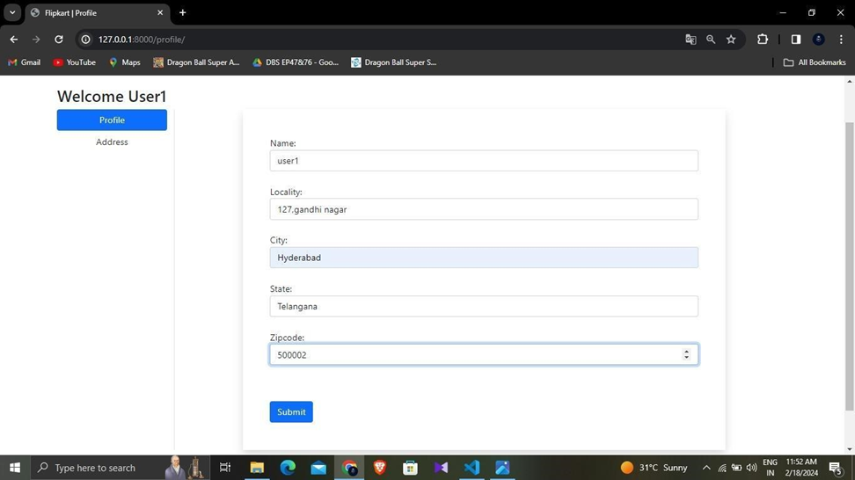

**Admin login:**

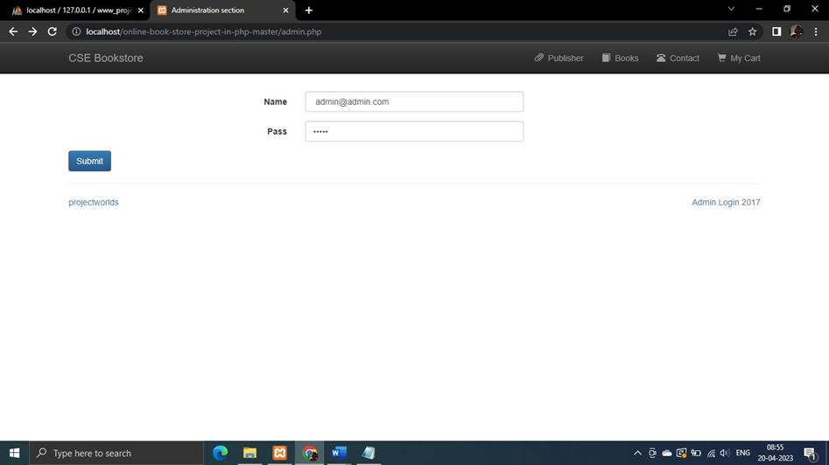

**Adding new books:**

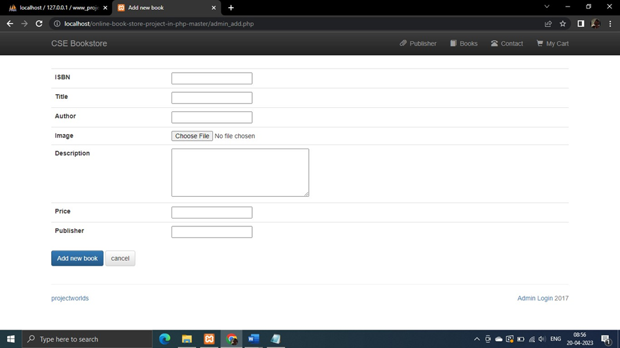

**CHAPTER - 7**

## 7. FUTURE ENHANCEMENT

For future enhancements to the "Online Book Store" project, several avenues can be explored to further elevate the platform's functionality, user experience, and competitive edge. One potential enhancement involves the integration of artificial intelligence (AI) and machine learning (ML) technologies to offer even more personalized recommendations to users. By analyzing user behavior, preferences, and interactions with the platform, AI algorithms can generate highly accurate book suggestions tailored to each individual's tastes and interests, enhancing discoverability and driving engagement.

Another area for future enhancement is the implementation of a robust customer relationship management (CRM) system to better understand and cater to the needs of users. By tracking customer interactions, feedback, and purchase history, the platform can develop more targeted marketing campaigns, loyalty programs, and promotional offers, fostering stronger relationships and increasing customer retention.

Furthermore, expanding the platform's capabilities to support multimedia content such as audiobooks, e-books, and digital magazines can broaden its appeal and cater to a wider audience of readers. Integrating with e-reader devices and platforms can enhance accessibility and convenience for users who prefer digital formats, further diversifying the platform's offerings and revenue streams.

Moreover, incorporating advanced analytics and reporting tools to provide administrators with deeper insights into user behavior, sales trends, and inventory management can enable data-driven decision-making and strategic planning, optimizing operational efficiency and driving business growth.

Lastly, exploring opportunities for internationalization and localization to support multiple languages, currencies, and shipping options can broaden the platform's global reach and appeal to a more diverse audience of users, opening up new markets and revenue opportunities.

By strategically implementing these future enhancements, the "Online Book Store" project can continue to evolve and innovate, remaining at the forefront of the online book retail industry and delivering exceptional value to users and stakeholders alike.

**CHAPTER - 8**

## 8. CONCLUSION

In conclusion, the Online Bookstore website project has been a success. The website has been designed and developed to provide users with a seamless experience when searching for, purchasing, and managing books online. Throughout the project, a range of software development methodologies, including Agile and Waterfall, were used to ensure that the project was delivered on time and within budget. The project was divided into several phases, including requirements gathering, system design, implementation, and testing, each of which was carefully planned and executed.

The website was designed with the user in mind, and the user interface was optimized for mobile devices. The website's features, including the book catalog, search functionality, shopping cart, and payment gateway integration, were implemented to ensure that users could easily find and purchase books online. The website was tested extensively to ensure that it was free from bugs and errors and provided users with a seamless experience. Different testing methodologies were used, including unit testing, integration testing, user acceptance testing, security testing, performance testing, and usability testing, to ensure that the website was thoroughly tested.

Overall, the Online Bookstore website project has been a success, and we believe that it will provide users with a valuable tool for purchasing and managing books online. We hope that the website will continue to be improved and updated in the future to ensure that it remains a leading platform for online book purchases.

**CHAPTER - 9**

## 9. BIBILOGRAPHY

1. Welling, Luke, and Laura Thomson. "PHP and MySQL Web Development." Addison-Wesley Professional, 2020. This comprehensive book provides in-depth guidance on building dynamic web applications using PHP and MySQL, covering topics such as database design, security, and optimization.

2. Ullman, Larry. "PHP for the Web: Visual QuickStart Guide." Peachpit Press, 2016. This practical guide offers step-by-step instructions and examples for learning PHP programming for web development, making it an invaluable resource for beginners and experienced developers alike.

3. DuBois, Paul. "MySQL Cookbook: Solutions for Database Developers and Administrators." O'Reilly Media, 2014. As a reference guide, this book offers a wide range of solutions and best practices for common MySQL database tasks, making it an essential resource for developers working with MySQL databases.

4. XAMPP Documentation. Available online at: https://www.apachefriends.org/docs/. The official documentation for XAMPP provides detailed instructions and resources for installing, configuring, and using XAMPP for local web development environments, making it an indispensable reference for developers working with XAMPP.

5. PHP Documentation. Available online at: https://www.php.net/docs.php. The official documentation for PHP offers comprehensive information on PHP programming language features, functions, and syntax, serving as an authoritative reference for PHP developers.

6. MySQL Documentation. Available online at: https://dev.mysql.com/doc/. The official documentation for MySQL provides detailed documentation on MySQL database features, SQL syntax, and administration, making it an essential resource for developers working with MySQL databases.

7. Online Tutorials and Forums. Websites such as Stack Overflow (https://stackoverflow.com/) and W3Schools (https://www.w3schools.com/) offer a wealth of tutorials, articles, and community forums where developers can find solutions to common programming challenges, share knowledge, and seek assistance when developing PHP and MySQL-based projects.

8. Project Management Tools. Tools such as GitHub (https://github.com/) or Bitbucket (https://bitbucket.org/) can be useful for version control, collaboration, and project management when working on software development projects like the online bookstore.